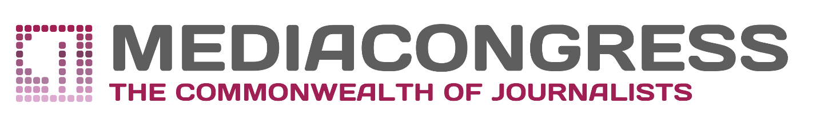

APPLICATION FORM

XIII International Media-Forum «Dialogue of cultures»
  - November 2018, St. Petersburg, Hermitage

- Full Name

- Photo
*Colored, in a good quality for both web-site and printed supplementary materials.

- Date of birth

- Passport details (number, series, valid by)

- Please, inform us whether you need accommodation or not (point the exact time and date of arrival and departure)

- Phone number

- E-mail

- Place of work (web-site/ position/ working address and telephone (home address and telephone for a freelancer)) / study

- Would you like to take part in the International journalistic festival and photo exhibition, linked by the common theme «Here I live»?
*If your answer is positive, write, please, what kind of project you would like to present and its name. It may be:
- Video, TV-spot, documentary;
- Photo or series of photos.
Deadline for submission – 24.09.2018

- Would you like to be a speaker on the practical conference or to present your cross-border media project (potential or already launched)?
*If your answer is positive, write, please, what kind of project you would like to present and its name. Deadline for submission – 01.10.2018

- Please indicate the topic chosen for your shooting in halls and storages of the State Hermitage/ in St. Petersburg and its surroundings.
*Please mind that some themes should be approved by the Legal Department of The State Hermitage Museum in advance. Deadline for submission – 01.10.2018

The Forum Organizing Committee couldn't confirm your participation without receiving this information. We would be happy to see your filled application form on our e-mail: mediacongress.russia@gmail.com and info@mediacongress.ru (please, send the copy of your application to this e-mail too).

